OK, here’s the deal guys I’m sending this to only my squad members. FYI that would be, DocSparky, Fragfood, Rollout, and MaggotPulse.
If you haven’t looked at the strategy Wetzny laid out, then look.. That’s the basic Idea. It may change some once we get in game, but the basic Idea should still work.
We are starting at Outskirts, our first goal is to cap City Entrance with the help of Alpha squad, after we have control of City Entrance, we are moving onto Surveillance post with Alpha. Alpha Squad with be going left at this point to help Delta out with Alleyway. Charlie squad should be near Surveillance, on the hill to our right suppressing anyone coming up from hotel. Once this is under control, we are linking up with Charlie squad at Surveillance and moving onto Construction site. After we cap Construction site, I think our main goal is to hold construction, and surveillance, or lend a hand in whatever area needs help. Obviously at this point, the game dynamics are going to be hard to predict, so we will play it by ear.
Now for more detail, I ran through the map a couple of nights ago and can up with some pointers for us.
Here are the Kits we are starting with.
YellowDog = Medic “I can keep myself going if I get hit, and also revive anyone who gets hit” Also if I go down, whoever is near me, take my kit and revive me. I don’t have to tell you guys that if we lose our Squad Leader at a forward point we haven’t captured yet, then we stand a chance of a setback if I have to come from the last capture point.
DocSparky = Assault “I plan on putting out 1 smoke grenade to cover our advance to city, I will point this out to you later”
Fragfood = Assault = “Same deal, smoke grenade to cover our advance”
Rollout = Medic “We always need more than 1, and you know what to do… med packs, reviving, and kill anything that moves.
MaggotPulse = Resupply “you can lay down some serious lead in a tight spot with the PKM. Also throw down supplies so we don’t run out of grenades… I got a feeling with the few roof tops we have to deal with, grenades are going to be in high demand.
I do not want any sniper kits at the start, but as things progress, if we see the need for one, then the next guy that dies spawn with it. I still think these guys are going to have snipers laid out in a few spots, and they may be more of a nuisance than a threat… Also, leaving a claymore or 2 in strategic spots when we leave a capture point to go defend or cap another may be a good Idea “Particularly construction site, like at the top of the ladder, the stairs, and so on.
Side note, stick with these kits at the beginning, but also be aware of each other’s roll. At some point you may end of with their kit, and I want everyone to be aware each other’s basic task so we remain flexible. My main point on kits, is we don’t all end up with Supply, Assault, Medics, or Snipers, if that happens then when we really need a REZ, Supplies, a Claymore laid out, or some smoke to cover our advance we may not have it.
So there you have it, the basic game plan, if possible one night when were all on, I would love to run through the map and show you guys the route we need to take, and some strategic points for the enemy as well as for us, and plus get some input from you guys… I know I’m not the most experienced one in our group, so I by no means think I know it all. I am up for any changes that will help us in achieving our goals.

First part of my strat, DO NOT SPAWN WHEN THE ROUND STARTS. Wait until I tell you guys to spawn, I will run flat out until I’m out of burst run, at that point you guys be ready to spawn, it’s only going to be a few seconds, but a few seconds count in this game. The advantage, you will be that much closer to the objective and still fully charged.
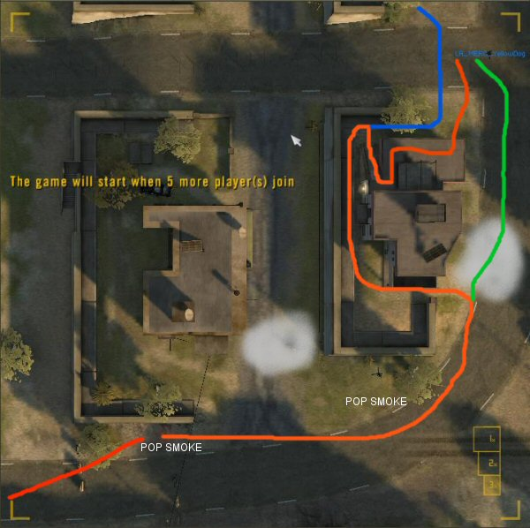
Ok the Assault on city as you can see in this first PIC.. Doc, you pop smoke at the first location, and Frag you take the second..my hope is this will not only provide us cover, but obstruct the view of Charlie squad behind us. Maggot and Rollout take the route between the building and wall, Maggot go up top to clear the second level, if he gets a claymore to the face, Rollout revive him, then continue on to the flag and maggot, clear out what you can off the flag before anyone gets there. Doc and Frag, you guys head on straight up the road to the flag… if no one is on the flag, then keep in mind there’s probably a claymore, so one at the time. I will be out of breath and lagging behind, but I will be there shortly, so if anyone is down when I get there, I hope to revive them on the way. Remember Alpha squad will be coming in also, so keep an eye out for these guys. We don’t need to T/K our own guys.

NEXT PAGE>>>>

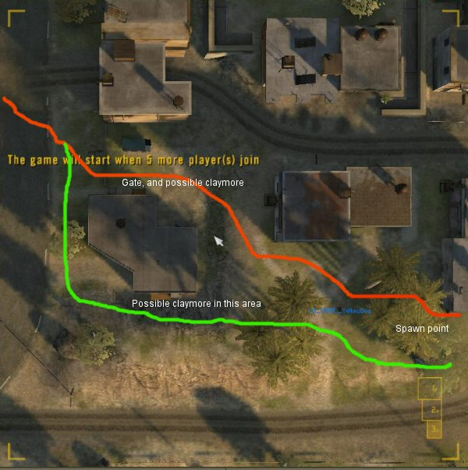
On the way to Surveillance we need to split into 2 groups, Maggot and rollout, take the gate route, Maggot first, if he gets hit, then Rollout revive him and keep going, DOC and FRAG, take the route around the far right building, I hope to be right behind you guys, so remember 1 at a time, if you go down I will revive you. Up ahead there is a spawn point, so be ready if someone spawns there. Doc and frag, I hope by the time you get to this point Maggot will have resupplied you guys with smoke, so pop one at the corner going into surveillance post. Again keep in mind Alpha will be headed here also from another route so keep an eye out for them when you reach Surveillance post.

Once we get there, “I forgot to point it out, but there is a roof top we need to lob a couple of grenades at.. I bet they will be there. Once we cap the flag, there are 2 exits out the block wall… keep in mind.. Claymores.. so again, 1 at the time, Medic revive and we push onto construction.
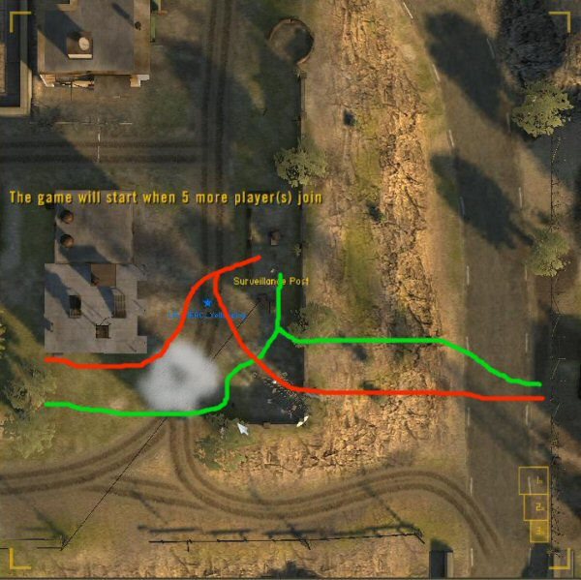

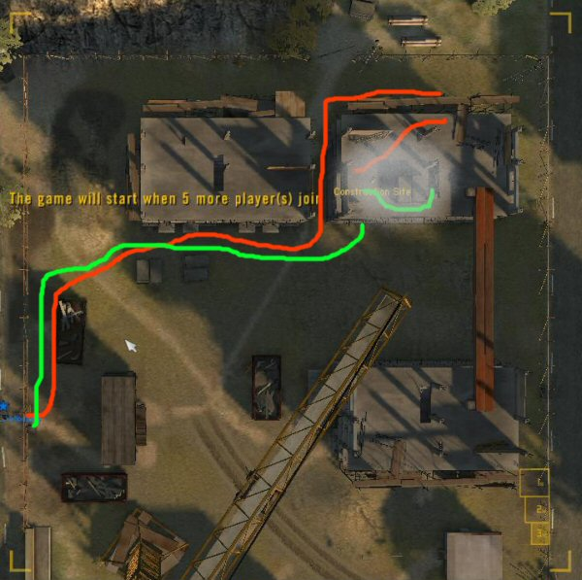
Now Construction we should be hooking up with Charlie, so look for them. Maggot and Rollout take the ladder, around the back of the building. Beware of a claymore at the top, Rollout it may be better to wait until Maggot makes it up the ladder first,, if he gets blown off.. Then revive and make another attempt… As for Doc and Frag, you know the deal, take the stairs, beware of claymores on the way up, I should be right behind you, I will revive you if you get hit. At the flag, either Doc or Frag pop smoke to guard us from getting picked off so easy, one of you guys should have another smoke grenade by now, if Maggot has been throwing down a few resupplies.
At this point if we have control of Construction, and I intend to keep it, along with surveillance. From hear on out we will play it by ear, adjust kits as we need them, try and suppress anyone out of TV and hotel, and maybe if the rounds looking good, go and take Hotel at some point.. But I think we can plan that far ahead.
Gentlemen, I think we have a good group of guys, all of which I know communicate well together.. So I think this plan is doable even if we don’t get much support from Alpha, or Charlie. SO LETS KICK SOME SNIPER GROUP ASS!!!

