OK, I drew up these Ideas for our squad, Charlie Squad… Providing we all make it then this plan should work out for both the US, and China side with just a little adjustment.

First of all, here’s our make up,

Yellowdog/Squadleader Charlie Squad/Armor Anti-Tank
DocSparky/Infantry-Armor Charlie Squad (playing Engie/or Anti-tank)
Rollout/Infantry-Armor Charlie Squad
1ManArmy/Infantry-Charlie Squad
FragFood/Infantry-Charlie Squad

On U/S… Me, DOC, and FragFood will spawn at the lower Main spawn, hop in a fast mover and make a mad dash for Cisterns. Rollout and 1ManArmy, y’all wait until we get to the cisterns then spawn on me. SO basically don’t spawn when the match start, wait till we get to cisterns. In the beginning our main objective is to Cap cisterns… I have the feeling we will have a fight on our hands, the best I can figure the china side, if they take the optimal route will beat us there by a couple of seconds, so be prepared… DocSparky, and I will start with the Engineer Kits, 1ManArmy and fragFood will be Antitank, and Rollout Re-supply.

Now the reason I need to 2 eng, and 1 antitank at the Cisterns to start.. We need to mine the Entrance’s to the Cisterns, and park whatever trucks we have in the entryway to stop the tanks from parking outside and laying down fire. The 1 antitank to take care of any enemy vehicles that gets through.

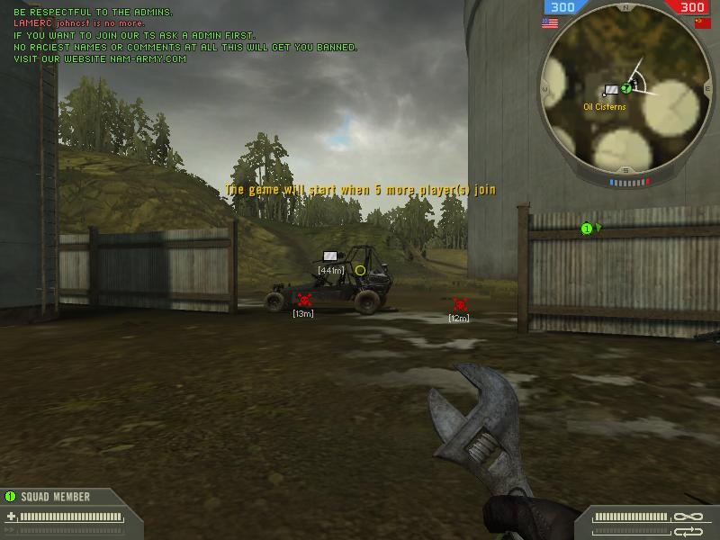

here is right entrance, towards the hills. “Note” the mine under the car. They wont see it, and if the try to move it… Boom..
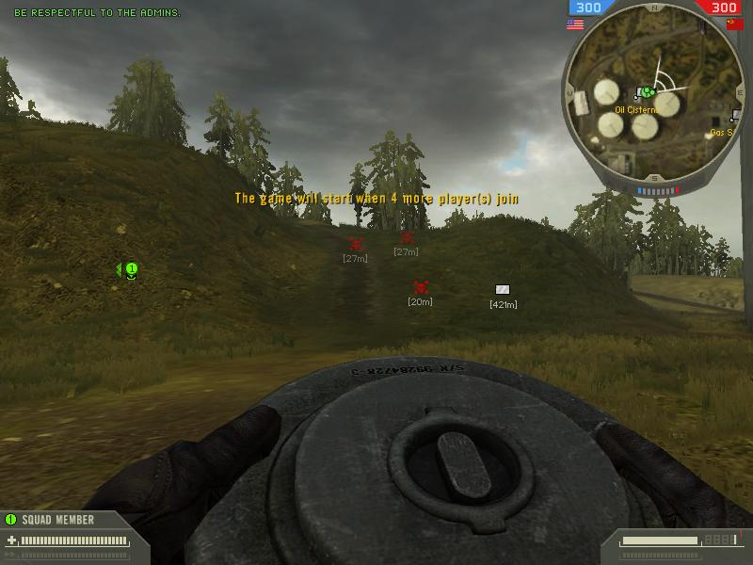

If we place 3 mines on the hill in from of the entryway in the last screen shot, they wont see it…

This is facing the China base, note the Red marks are mine placement, and the Yellow Rectangle is a Vehicle.

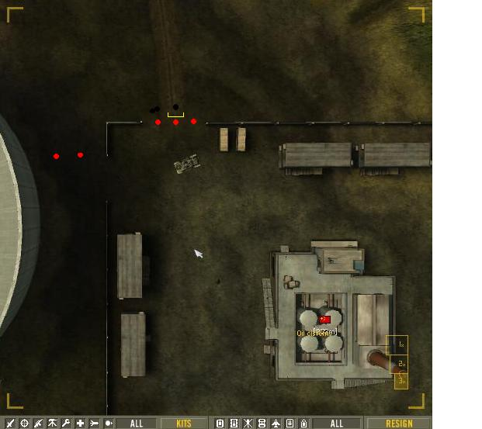

Note the group of 3 mines, this is the hill in the earlier pics, and the same deal that the gate. We need to try and place our mines as far under the vehicle as we can.

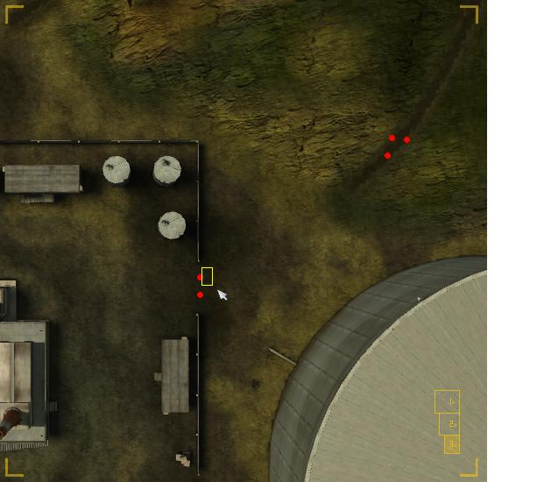

Our rear entrances should be watched by the choppers, but once we fight off the first wave, we should try to place mines at our rear entrances to prevent a rear assalt… this should be ever harder for them to do, as they will have to go all the way around us to get there, but no need in taking any chances. Also note the one in the middle of the nowhere… Well if they jump the ramp to get in… BOOM, they land on it.

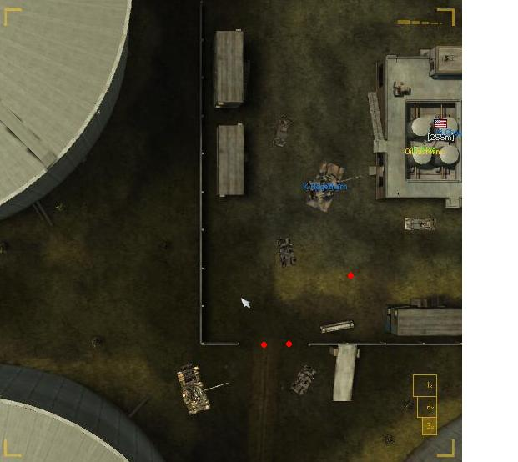

And of course the right rear entrance.. Not likely, but you never know… Now like I said earlier, this is secondary defense, only if we get control of the Cisterns.

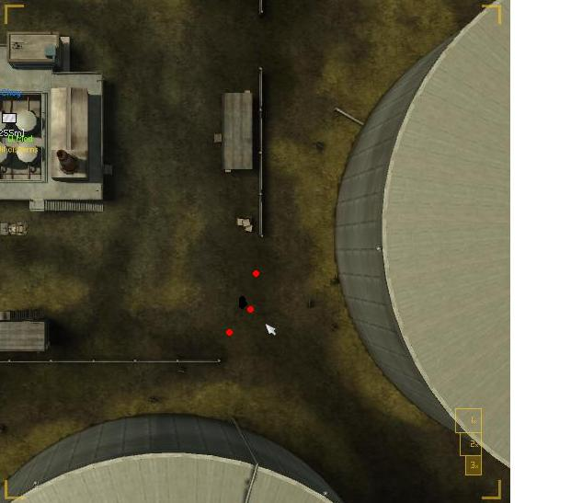

We do not need to be worried about the refinery, as from what I understand, our Fighter Hellos will take that, and defend from the air… If for some reason we loose the Cisterns we will fall back to the Refinery and fight our way back in.. At that point it will be an adjust to the situation type game play… can’t really plan a Re-capture strategy.

